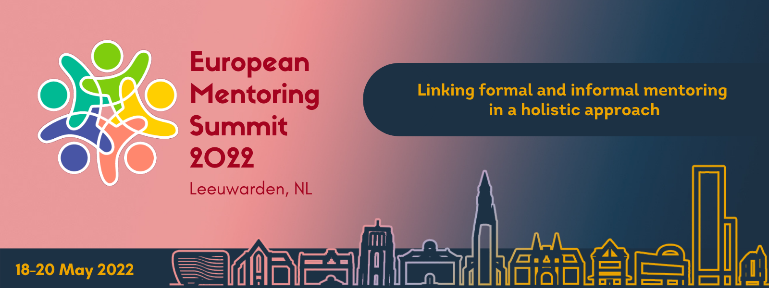

We are happy to inform you about the upcoming EUROPEAN MENTORING SUMMIT from 18th to 20th May 2022, in Leeuwarden, the Netherlands. This summit will bring together professionals, practitioners, researchers, mentors, mentees, corporate partners, government and civic leaders and students who represent the mentoring movement in Europe and beyond. The summit is therefore a great opportunity to strengthen your network, to get to know the diversity of the mentoring scene and to gain and pass on new insights from practice and research.
The 2022 edition of the European Mentoring Summit will focus on the following theme:
“Linking formal and informal mentoring in a holistic approach”

Mentoring helps build bridges between people of different backgrounds. It encourages young people in their development; it supports immigrants to settle into their new environments and it connects starters to established entrepreneurs around them. Despite the diversity of the target groups and forms of mentoring, it is the sustainable, tailor-made and resilient relationship between the mentor and mentee that forms the basis; it is also the starting point for powerful results.
Mentoring can build solid bridges between schools, social partners, businesses and families and it helps to create inclusive eco-systems. By connecting the world of formal and informal mentoring, we can work together for the benefit of mentees. We learn from each other, on all levels, in an integrated way.
For this reason, we have chosen ‘Linking formal and informal mentoring in a holistic approach as the major theme for the 4th EUROPEAN MENTORING SUMMIT. Keynote speakers and session leaders will challenge our understanding of how and under which conditions mentoring works. Practice – research collaborations will be introduced, offering us new insights and success strategies. European mentoring programmes will present their unique methods, tools, organizational models and activities. Altogether, the event will bring together 250+ people from Europe and beyond.
The 2022 EUROPEAN MENTORING SUMMIT is the 4th edition after the summits in Barcelona (2020), Berlin (2018) and Leeuwarden (2016). The 2022 summit will be hosted in Leeuwarden, in the North of the Netherlands, by Mentoring Europe, in collaboration with International Affairs of NHL Stenden University.

